Extract from Portsmouth News 22 May 15

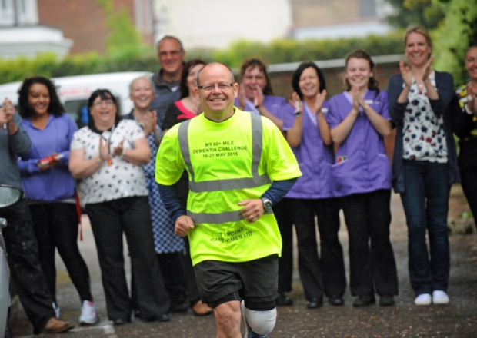

Steve Docherty is waved off by staff and residents at St Vincent House residential home in Gosport as he starts a weeks-worth of charity challenges to raise money for Dementia Awareness. Picture: Ian Hargreaves (150844-1)

UNEXPECTED hailstorms and a tumble off his bike didn’t stop a fundraiser from completing a four-day challenge for dementia care homes.
Steve Docherty, pictured, totted up more than 60 miles by running and cycling over the past four days during Dementia Awareness Week.
The 52-year-old, who is an executive advisor for company St Vincent Care Homes, which specialises in dementia care, ran and cycled between each of the firm’s four homes in Gosport, Southsea and two on the Isle of Wight.
He said: ‘It was quite tough – more so because of the weather which I wasn’t expecting to be so bad.
‘When I was running by the Hilsea Lido it was particularly windy and that was very difficult.
‘Although I knew it was going to rain, I didn’t expect the hailstones so that was something that also added to the challenge.
‘I also took a stumble on the Isle of Wight and by the end of it my legs were very tired.
‘But it was absolutely worth it because I wanted to raise money for each of the homes as that will go directly into helping residents.’
Steve’s journey saw him run 14 miles on Monday, cycle 22 miles on Tuesday, another 22-mile cycle on Wednesday and a 13-mile cycle and run to Gosport yesterday.
Each of the four homes has been asking staff, visitors and families for contributions – with the care home firm promising it will match any funds raised up to £500 for the home that collects the most money.
Steve added: ‘I’m hoping I will have raised up to £1,000, which will be fantastic.
‘I will definitely do something again though it will probably be something completely different.’

Extract From Portsmouth News 19 Jun 15

Steve cycles and runs more than 60 miles to raise charity cash

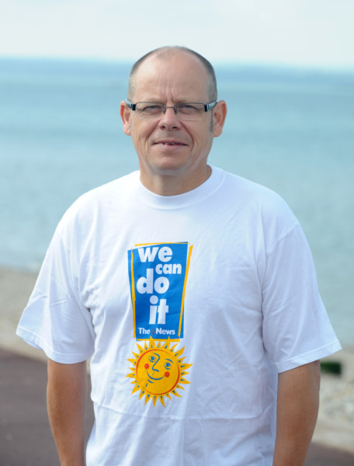

Cycling and running more than 60 miles to raise money for a charity is a big challenge.
That’s why executive advisor for St Vincent Care Homes Steve Docherty is this week’s We Can Do It T-shirt winner.
Steve battled wind, rain and hail to complete a four-day fundraising challenge last month.
The 52-year-old ran between the four homes he and his company, St Vincent Care Homes, look after across Gosport and the Isle of Wight.
And after embracing all of the incredible support the homes gives its residents, Steve wanted to give something back.
‘It’s payback really,’ he says.
‘I wanted to help them raise some money by doing a challenge of something I didn’t know if I could complete.’
The journey took place during Dementia Week - a week dedicated to raising awareness of the condition.
Steve adds: ‘Throughout it all, I was thinking about how much money the staff had raised and I didn’t want to let them down.
‘On the final day I had a five-mile cycle to finish it and I was getting tired, but I was able to fly through the last leg. ‘
On the first day, Steve ran 13 miles from Gosport to Clarence Parade, in Southsea.
He then cycled 21.5 miles from Southsea, across the water on the Fastcat to the Isle of Wight and across the island to the care home at Totland Bay.
The same distance was cycled again on the Wednesday to Sandown before Steve ran seven miles on the Thursday morning to Ryde. He finished the challenge with a five-mile cycle to the head office in Lee-on-the-Solent.
Each home raised their own charitable funds with residents, staff and families all donating. Gosport’s home raised the most across the premises with more than £500 donated.
Steve says: ‘When we do it again next year, I do think it will bring a nice piece of rivalry between the homes as each one wants to claim to have raised the most.
‘But I dont know how I am going to be able to challenge myself again next year.’

